Thank you for the opportunity to revise our manuscript for consideration in *American Journal of Epidemiology*. We found the comments to be constructive and helpful, and we have substantially revised our article accordingly. This revision involved changes to the manuscript text as well as addition of new sensitivity analyses. We have amended Figures 3-5 to be on the same scale to highlight the racial differences. Lastly, we have updated the analysis to include new data that had been incorrectly excluded from the previous version of our manuscript, and the results are substantively identical. Below, we list the Reviewers’ advice followed by a detailed description of what we did to address each comment (in italics).

**Reviewer: 1  
  
Comments to the Author**

This study (AJE-00390-2023) uses a novel combination of existing data sets and interrupted time series analyses to examine the impact of the murder of George Floyd on the mental health of residents of Minneapolis, focusing on effect modification by race/ethnicity. They report an increase in mental health diagnoses among Black residents, specifically, arguing that this is consistent with a model in which police violence is a traumatizing experience with direct implications for mental health. This is a timely and important topic, the methods appear sound, and conclusions are appropriate. Specific comments follow by section.  
  
There have recently been several theoretical/conceptual models of police violence & mental health published (for example, in DeVylder review in Annual Review of Clinical Psychology), which may inform the introduction, particularly the discussion of why police violence may be a particularly impactful risk exposure, as well as the protective effects of things like community mobilization following events like the death of George Floyd. Intro would also benefit from citing some of the work by Sewell, Ross, and Bowleg on this topic. While I agree with the benefits of a concise intro, this is some key work that is highly relevant to the study, particularly since it provides some exceptions to the assessment in the intro that most of this work has been based on self-report data and limited consideration of geography (see especially the Ross article).

*Thank you for making these points. We have amended the introduction to include work from Sewell, Ross and Bowleg (as well as DeVylder and colleagues) on police violence and mental health. Specific text is as follows:*

“Bowleg and colleagues introduce the concept of the Anti-Black Police Violence Continuum, which underscores that the range of violence inflicted by police is a manifestation of anti-Black structural racism”6

“Further, a recent review found that police violence has significant negative health effects, particularly for Black, Latine and other marginalized communities.9 The full physical and mental trauma caused by police is unknown due to poorly documented or comprehensively collected data. One study examining county-specific risk of police shootings found that the probability of being Black, unarmed and shot by police was 3.49 times higher than the probability of being white, unarmed and shot by police.15 However, current research lacks ~~fine-grained~~ more resolute spatial and temporal data which limits…”

Adjustment for seasonality was done using several proxy indicators (avg temperature, etc.), but not with any sort of use of non-linear trends. Can the authors say a little more about this decision? Discussion of the study design and analytic plan is otherwise very clear and well supported in the text.

*We conducted additional sensitivity analysis using non-linear time trends. Specifically, we introduce a quadratic polynomial in the pre- and posttreatment periods. Our primary specifications are robust to the nonlinear trends. The post-killing increase for Black residents is modestly increased, and the others are relatively similar. The random effect models w/ nonlinear trends tell a very similar story to the primary random effect specifications, and the interaction terms are nearly identical. Please see tables below and in our Appendix.*

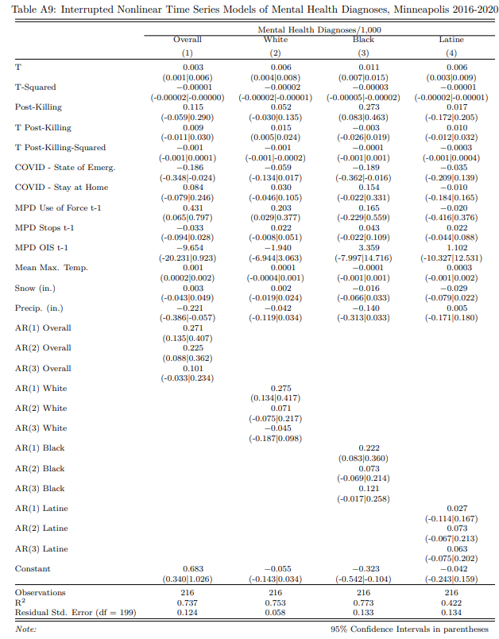

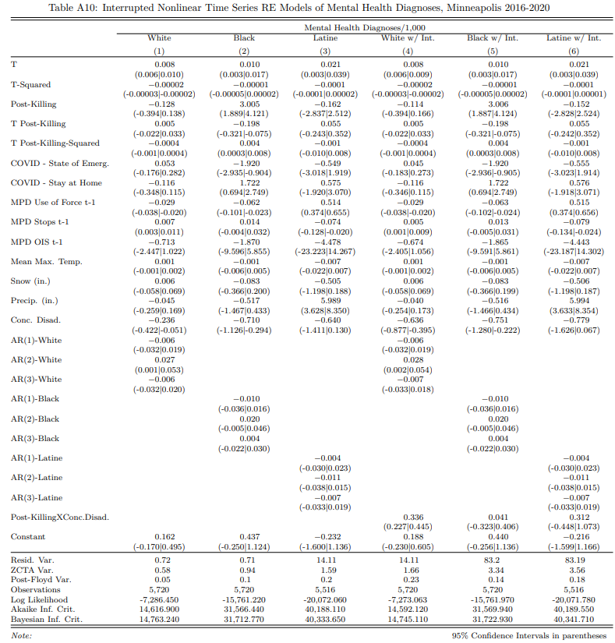  
Figures and tables all appear to be appropriate, and are all easy to understand. The effect modification analyses (by disadvantage, race, p.11-12) are well done and informative.

*We appreciate this comment. Thank you.*

This study found an increase in rates of diagnosis among Black individuals despite prior evidence that police violence can lead to greater rates of medical mistrust, suggesting that these effects may actually be under-estimates of the true increase in distress/mental health health symptoms in the wake of the George Floyd murder. This should be mentioned in the discussion. This is alluded to on p. 12-13, but I think it can be safely stated how this is likely to impact the results (in terms of direction of bias).  
  
 *Thank you for making these points. We have amended the discussion to make this point. Specific text is as follows:*

“First, hospital discharge data only captures mental health diagnoses among those who went to the hospital for care, ie. more serious cases. Mental health stigma, a lack of health insurance, or medical mistrust, which is fostered by police violence exposure, could serve as barriers to seeking hospital care.32 This self-selection of not receiving health care could have also been exacerbated because of COVID-19. However, our study found an increase in rates of diagnosis among Black individuals despite prior evidence that police violence can lead to greater rates of medical mistrust, suggesting that these effects may actually understate the true increase in distress/mental health symptoms in the wake of the murder of Mr. Floyd .”

**Reviewer: 2  
  
Comments to the Author**  
  
This manuscript identifies the impact of the murder of Mr. George Floyd on rates of mental health hospital discharge at the city-level in Minneapolis, Minnesota. This paper builds upon previous work that primarily included cross-sectional studies, self-reported measures, and limited consideration of geography. Overall, this is strong study however I have a few comments to improve the manuscript below.  
  
The introduction could be strengthened by discussing why it’s important to look at hospitalizations as a metric of mental health beyond self-report. While obvious, I think the paper could also benefit from a few sentences on the importance of looking at mental health (especially given the focus of the special issue).

*Thank you for making these points. We have amended the introduction to include a benefit of using hospital records. Specific text is as follows:*

“b) using an alternative measure of mental health diagnosis which provides population-based estimates of mental health diagnoses that are potentially less susceptible to social disability bias than self-reports”

Methods  
Please include all the ICD-10 codes used to create the mental health outcome. I would like to see this in a table with information on the % of how much each code is contributing to the total number. There also needs to be additional justification for the combination of all these outcomes together. Were the authors able to disaggregate acute mental health hospitalizations versus chronic? I would be interested in seeing results for disaggregated mental health outcomes such as depression and anxiety. What were the overall rates of hospitalizations for these outcomes during the study period?

*We understand the necessity to understand the contribution of each ICD code to the total. We have added language (specific text are as follows) and an appendix table to include the percentage, total number of each code, and rates of hospitalization for our mental health outcomes during our study period.*

*Similarly, we agree it is important to disaggregate and examine individual subtypes of hospital diagnosis codes. Below we have included analysis of 5 subtypes: the three largest sub categorizations of mental health: anxiety (MBD005), depression (MBD002) and* alcohol disorders (MBD017)*; and two smaller diagnoses of acute (Acute stress reaction F43.0 and Post-traumatic stress disorder, acute F43.11) and chronic (Post-traumatic stress disorder, chronic F43.12). We include below the model tables for anxiety disorders, depression disorders, alcohol disorders, acute and chronic diagnoses. We also include the full analytic results by subtype for anxiety, depression and alcohol disorders in the appendix. We did not include the full analytic results (here or in the appendix) for acute and chronic diagnoses because of concerns with sample size.*

*Generally, our overall results are replicated with the depression and alcohol diagnoses sensitivity analyses. The anxiety models do not display a racial pattern as in our primary findings, and the acute/chronic outcomes both show no change from pre-treatment levels. It is important to note, that there is small sample size for both the acute and chronic diagnoses codes, therefore, we believe these results should be interpreted with caution.*

*“*They are categorized based on established mental, behavioral and neurodevelopmental disorders diagnoses groupings using ICD-10 codes F01–F99.17 A table of the codes can be found in the Appendix Table 1.”

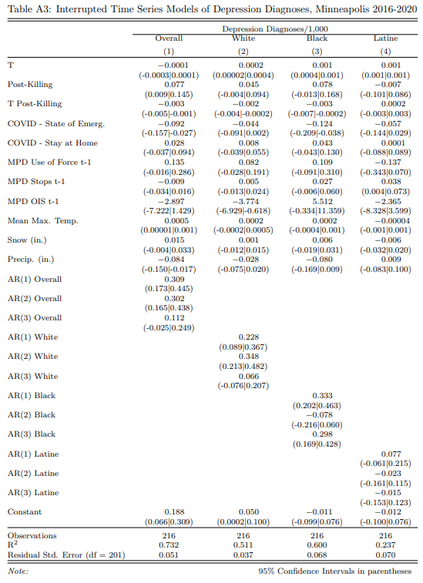

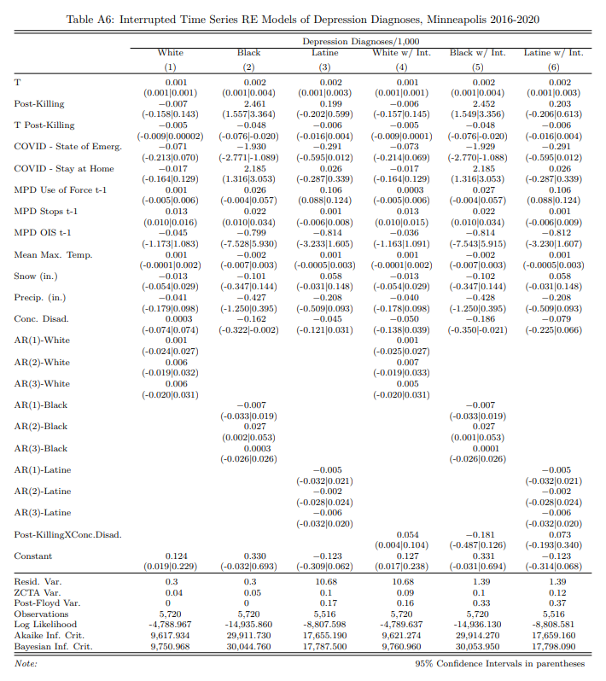

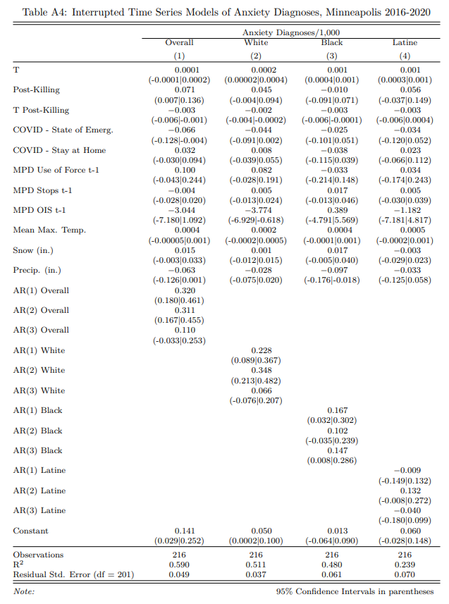

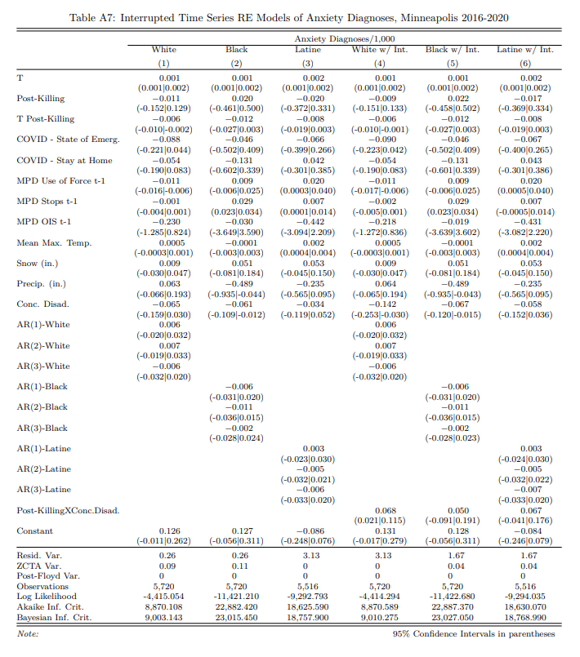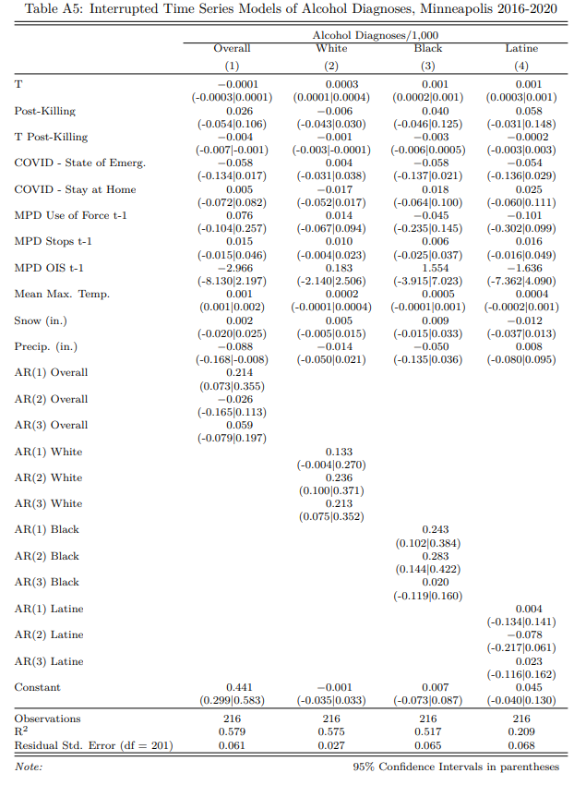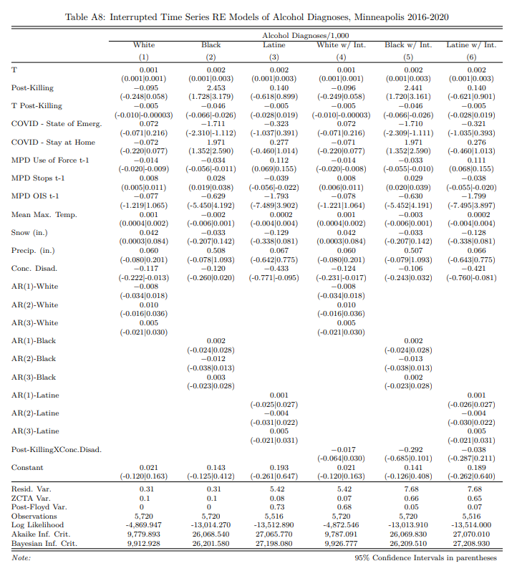

|  |  |  |  |  |
| --- | --- | --- | --- | --- |
| Appendix Table 1: Individual Distribution of Mental Health Diagnoses, Minneapolis 2016-2020 | | | | |
| Diagnoses | Clinical Classification Software Refined | Frequencya | Percentage | Weekly Rate of Hospitalization per 1,000 Residents |
| Schizophrenia spectrum and other psychotic disorders | MBD001 | 45808 | 7.5% | 0.264 |
| Depressive disorders | MBD002 | 95248 | 15.6% | 0.644 |
| Bipolar and related disorders | MBD003 | 25528 | 4.2% | 0.169 |
| Other specified and unspecified mood disorders | MBD004 | 9458 | 1.5% | 0.062 |
| Anxiety and fear-related disorders | MBD005 | 93484 | 15.3% | 0.608 |
| Obsessive-compulsive and related disorders | MBD006 | 1932 | 0.3% | 0.015 |
| Trauma- and stressor-related disorders | MBD007 | 31231 | 5.1% | 0.21 |
| Disruptive, impulse-control and conduct disorders | MBD008 | 3780 | 0.6% | 0.024 |
| Personality disorders | MBD009 | 15571 | 2.5% | 0.111 |
| Feeding and eating disorders | MBD010 | 1946 | 0.3% | 0.013 |
| Somatic disorders | MBD011 | 1367 | 0.2% | 0.009 |
| Suicidal ideation /attempt /intentional self-harm | MBD012 | 33476 | 5.5% | 0.205 |
| Miscellaneous mental and behavioral disorders/conditions | MBD013 | 4364 | 0.7% | 0.029 |
| Neurodevelopmental disorders | MBD014 | 17087 | 2.8% | 0.117 |
| Alcohol-related disorders | MBD017 | 121153 | 20.0% | 0.674 |
| Opioid-related disorders | MBD018 | 21400 | 3.5% | 0.14 |
| Cannabis-related disorders | MBD019 | 19418 | 3.2% | 0.136 |
| Sedative-related disorders | MBD020 | 2500 | 0.4% | 0.017 |
| Stimulant-related disorders | MBD021 | 29014 | 4.7% | 0.178 |
| Hallucinogen-related disorders | MBD022 | 933 | 0.2% | 0.006 |
| Inhalant-related disorders | MBD023 | 231 | 0.0% | 0.001 |
| Tobacco-related disorders | MBD024 | 340 | 0.1% | 0.003 |
| Other specified substance-related disorders | MBD025 | 23874 | 3.9% | 0.146 |
| Mental and substance use disorders in remission | MBD026 | 10259 | 1.7% | 0.068 |
| aThe total count will not sum to the sample size because there could be multiple diagnoses per individual | | |  |  |
|  | | |  |  |

Results  
For the last sentence in the results, ‘In general, these patterns of results establish the spatially racialized character of the harmful effects of police violence, where Black residents experience a universal harm and the negative effects for White residents are confined to those disadvantaged.’ Do the authors mean to those in disadvantaged ZCTAS? Neighborhoods? It seems to me that the level of disadvantage is calculated at the neighborhood-level and not the individual-level correct. I would make this clear in the interpretation.

*Thank you for making this point. The ZCTA is the unit of analysis. We have amended the language to make sure the interpretation is clear. Please see text below.*

*“*In general, these patterns of results establish the *spatially racialized* character of the harmful effects of police violence, where Black residents experience a universal harm and the negative effects for White residents are confined to those located in disadvantaged spaces”*.*